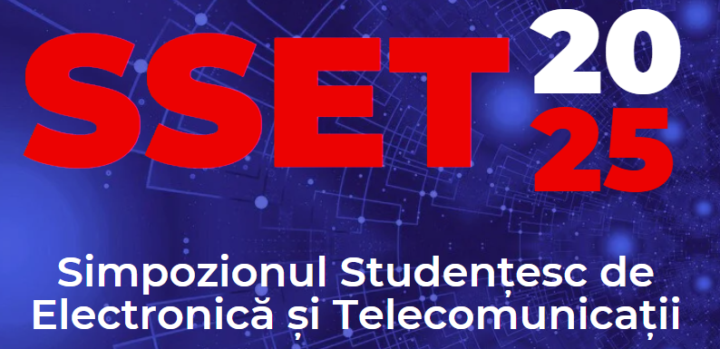
Copyright Form

The SSET organizing committee has developed this form with great care and with the best interests of its members and contributing authors in mind. When completed, this form must accompany any scientific paper published in printed copy by Napoca-Star and the paper's Abstract to be published online in Novice Insights magazine. All paper authors must sign this form, including the coordinating/advisor professor. Please read it carefully and keep a copy of it for your records.

TITLE OF PAPER: .................................................................................................................

..................................................................................................................................................

AUTHOR(S) AND AFFILIATIONS:

1. ................................................................................................................................

2. ................................................................................................................................

3. ................................................................................................................................

4. ................................................................................................................................

This undersigned form assigns all copyright rights in and to the above work to the SSET. This document represents and warrants that the work is original and that he/she is the work's author, except possibly for material such as text passages, figures, and data that identify the source, with permission notices from the copyright owners where required. The undersigned represents that he/she has the power and authority to make and execute this assignment. This form is intended for original, previously unpublished material. The undersigned guarantees that the work is not and will not be published in another journal/conference in his country or abroad.

…………………………………..……………………………….. …………………….
Title and name of the 1st author Signature

…………………………………..……………………………….. …………………….
Title and name of the 2nd author Signature

…………………………………..……………………………….. …………………….
Title and name of the 3rd author Signature

…………………………………..……………………………….. …………………….
Title and name of the 4th author Signature

Date, XX.05.2025

